

**Course Title:** Web Programming

**Course Code:** CSE479

**Section:** 2

**Title: Blood Bank Management System**

**Submitted To:**

**Jesan Ahammed Ovi**

Senior Lecturer  
Department of Computer Science & Engineering

**Submitted By:**

MD. Azman Ahmed

ID:2020-1-60-217

Department of Computer Science & Engineering

**1. Project Description:**

The "Blood Bank Management System" is a project aimed at efficiently managing the operations and resources of a blood bank. It provides a centralized platform to streamline various activities such as blood donation, blood inventory management, blood request processing, and donor management. The system enables users to register as donors, schedule and track blood donations, check blood availability, and submit blood requests. It facilitates the coordination between blood donors, recipients, and the blood bank staff, ensuring the timely and secure handling of blood-related processes. Overall, the project aims to enhance the accessibility, efficiency, and transparency of blood bank operations, ultimately helping to save lives by ensuring an adequate supply of blood and optimizing the utilization of resources. **2. System Requirements:**

**Processor**: A modern processor, such as an Intel Core i3 or equivalent, would be sufficient for development purposes.

**RAM**: At least 4 GB of RAM is recommended for smooth development and testing. However, if working with larger datasets or running resource-intensive operations, more RAM may be beneficial.

**Operating** **System**: The choice of operating system depends on your preferences and the compatibility of the technologies you plan to use. Common options include Windows, macOS, and Linux.

**IDE** (Integrated Development Environment): You can choose from several popular IDEs for Python development, such as PyCharm, Visual Studio Code, or Sublime Text. These IDEs offer features like code editing, debugging, and project management to streamline your development workflow.

**3. System Design:**

The architecture of the Blood Bank Management System project can be designed using a typical web application architecture. Here's a high-level overview of the system design:

**Presentation Layer:** The user interface (UI) is developed using HTML, CSS, and JavaScript.

The UI interacts with the backend through HTTP requests.

**Application Layer:** Flask, a Python web framework, is used to handle the application logic and serve the webpages. Flask routes define the various endpoints for handling user requests and rendering appropriate responses.User input validation and processing are performed in this layer.

**Data Access Layer:**

The system utilizes a database to store and retrieve data.MongoDB is used to interact with the database.

The technology stack used to develop the Blood Bank Management System can include:

Python

Flask

HTML

CSS

Javascript

MongoDB

**4. Features:**

**User**:

* Can create user account
* Donate blood
* Check inventory
* Request for blood
* Log out

**Admin**:

* Add blood to inventory
* Manage user accounts

**5. Results:**

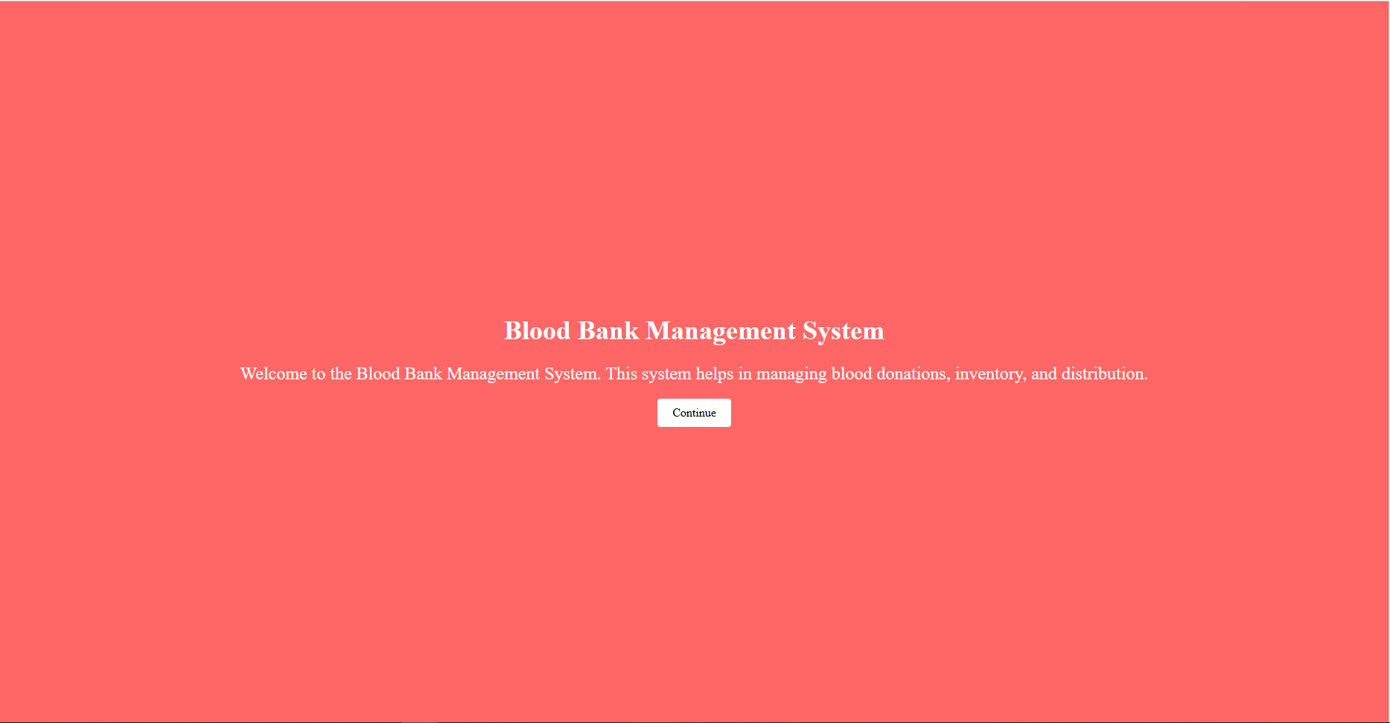

This is the first page, from here we can go to the log in interface of user**.**

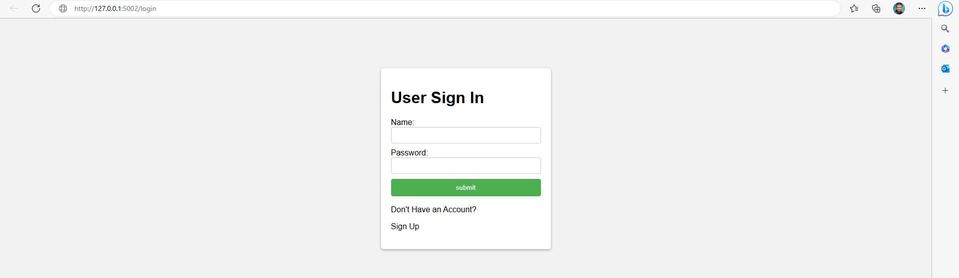

From here we can login using previously created account using name, email and password, Or we can click on to sign up to create a new account.

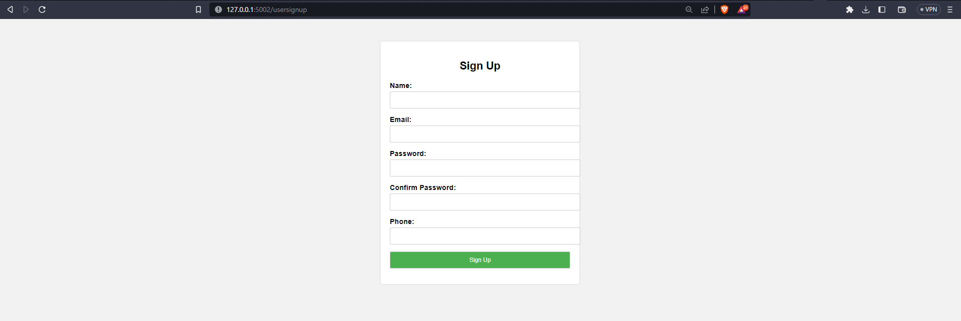

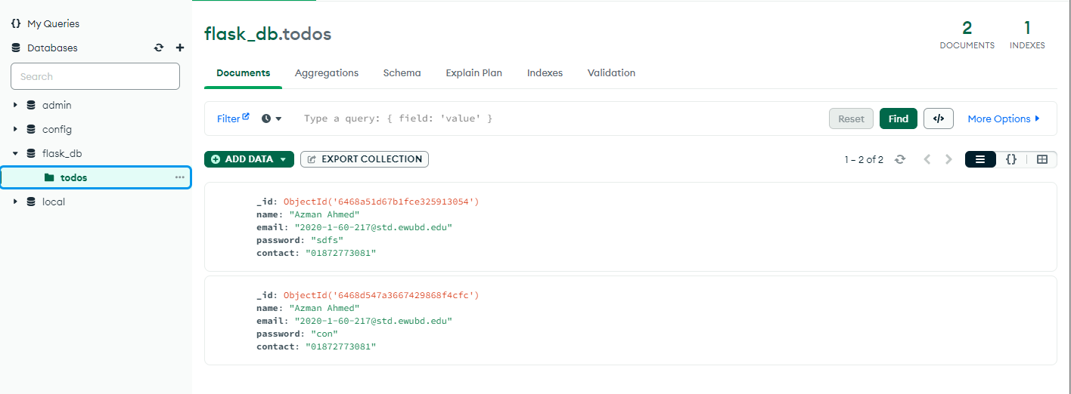

Data is updated in the database MongoDB

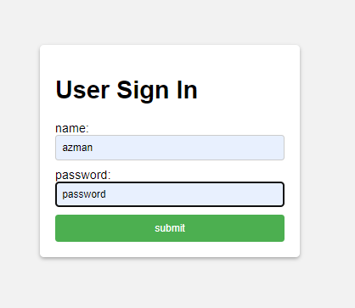

Now if we sign in here it will us to front page where the system asks what the user want to do: (Donate, check inventory or Request for blood)

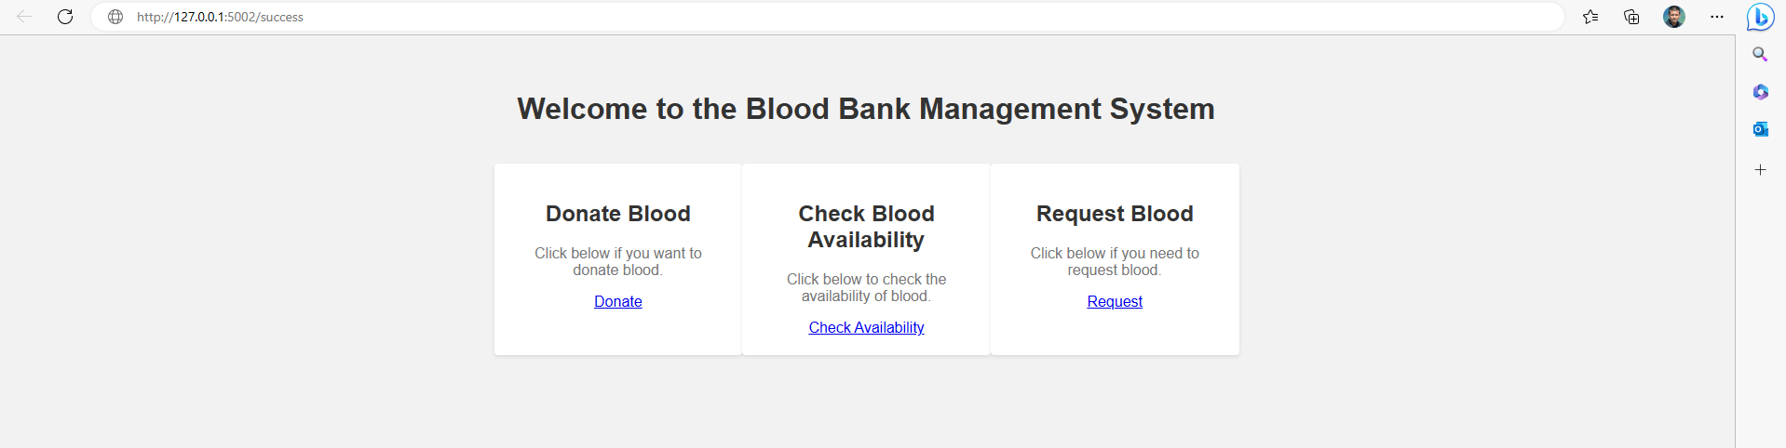

From here if the user selects the donate blood option it will generate a form where he can input his personal and medical information

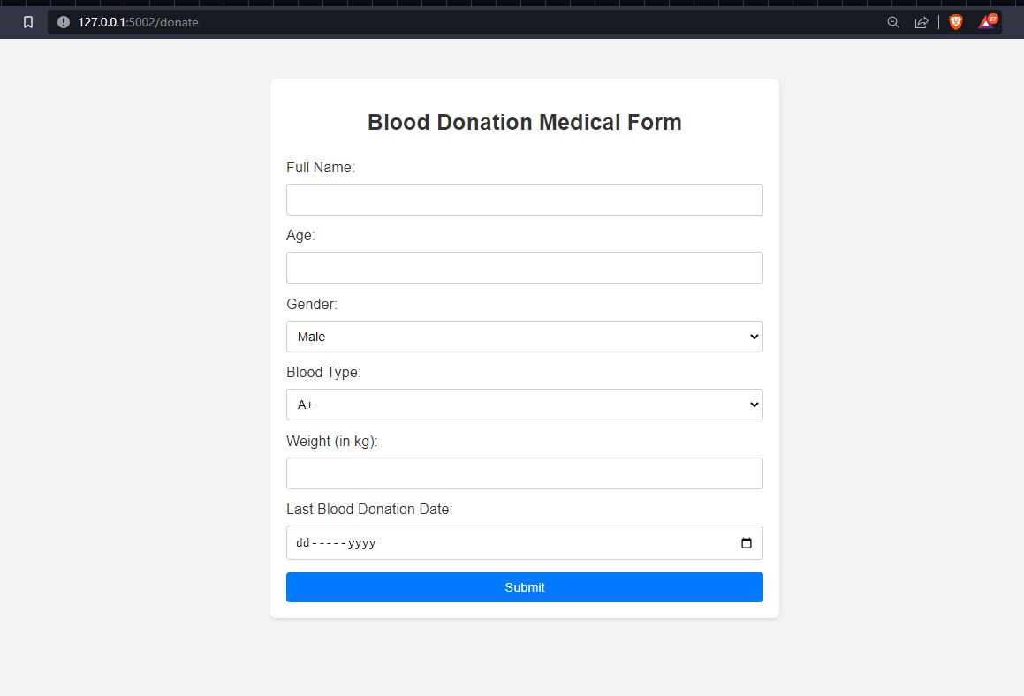

After filling up the form successfully a receipt will be generated in the name of user which he can take to blood bank center and donate blood.

A user can also check the availability of blood of any type

A user can request for blood, then a receipt will be generated which he can take blood bank center where he/she will be provided according to his needs after some verification **6. Future Scope:**

Future scope of my project “Blood Bank Management System”:

1. We can connect this app with map to navigate the closest blood bank center. It will be easier for users and also efficient in the case of emergencies